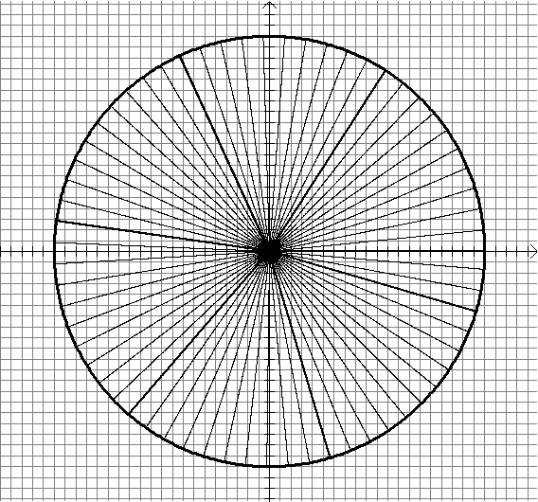Given angle θ in radians, compute approximations to the trig values using the point (x,y) with x = cos(θ) and y = sin(θ)

Unit Circle with grid blocks of width 0.05 and angle grid with increments of 0.1 radians

Dr. John Travis, Mathematics Department, Mississippi College

